DBMS Tutorial
DBMS Tutorial provides basic and advanced concepts of Database. Our DBMS Tutorial is designed for beginners and professionals both.
Database management system is software that is used to manage the database.
Our DBMS Tutorial includes all topics of DBMS such as introduction, ER model, keys, relational model, join operation, SQL, functional dependency, transaction, concurrency control, etc.

What is Database
The database is a collection of inter-related data which is used to retrieve, insert and delete the data efficiently. It is also used to organize the data in the form of a table, schema, views, and reports, etc.
Backward Skip 10sPlay VideoForward Skip 10s
For example: The college Database organizes the data about the admin, staff, students and faculty etc.
Using the database, you can easily retrieve, insert, and delete the information.

Database Management System
- Database management system is a software which is used to manage the database. For example: MySQL, Oracle, etc are a very popular commercial database which is used in different applications.
- DBMS provides an interface to perform various operations like database creation, storing data in it, updating data, creating a table in the database and a lot more.
- It provides protection and security to the database. In the case of multiple users, it also maintains data consistency.
DBMS allows users the following tasks:
- Data Definition: It is used for creation, modification, and removal of definition that defines the organization of data in the database.
- Data Updation: It is used for the insertion, modification, and deletion of the actual data in the database.
- Data Retrieval: It is used to retrieve the data from the database which can be used by applications for various purposes.
- User Administration: It is used for registering and monitoring users, maintain data integrity, enforcing data security, dealing with concurrency control, monitoring performance and recovering information corrupted by unexpected failure.

Characteristics of DBMS
- It uses a digital repository established on a server to store and manage the information.
- It can provide a clear and logical view of the process that manipulates data.
- DBMS contains automatic backup and recovery procedures.
- It contains ACID properties which maintain data in a healthy state in case of failure.
- It can reduce the complex relationship between data.
- It is used to support manipulation and processing of data.
- It is used to provide security of data.
- It can view the database from different viewpoints according to the requirements of the user.

Advantages of DBMS
- Controls database redundancy: It can control data redundancy because it stores all the data in one single database file and that recorded data is placed in the database.
- Data sharing: In DBMS, the authorized users of an organization can share the data among multiple users.
- Easily Maintenance: It can be easily maintainable due to the centralized nature of the database system.
- Reduce time: It reduces development time and maintenance need.
- Backup: It provides backup and recovery subsystems which create automatic backup of data from hardware and software failures and restores the data if required.
- multiple user interface: It provides different types of user interfaces like graphical user interfaces, application program interfaces

Disadvantages of DBMS
- Cost of Hardware and Software: It requires a high speed of data processor and large memory size to run DBMS software.
- Size: It occupies a large space of disks and large memory to run them efficiently.
- Complexity: Database system creates additional complexity and requirements.
- Higher impact of failure: Failure is highly impacted the database because in most of the organization, all the data stored in a single database and if the database is damaged due to electric failure or database corruption then the data may be lost forever.

DBMS
DBMS stands for Database Management System, which is a tool, or a software used for the creation, deletion, and manipulation of the data in the database. DBMS helps users to insert new data sets into the existing database or delete some data from the database. DBMS allows users to share the database, which means multiple users can access the database and use its data. DBMS also makes sure that the data will be consistent and secure. In DBMS, we can define our own data structure and data with specific constraints. DBMS uses various algorithms for securing its data from cyber-attacks. So, we can define the DBMS as an interface between the database and the user. DBMS is evolving with time, and we can see artificial intelligence-based database management systems after a few times.

File System
The file management system is also a database management system where data is stored in the form of files. It is an old traditional way to store the data in the files. Each file does not have any relation with other files. Tables are stored in the files, and sometimes only a single table is stored in a file which is also known as a flat file.

Advantages of DBMS over File Systems
- Data Redundancy and Inconsistency:
Redundancy means repeating the data in a system. In a normal file system, there is a high chance that there can be various files of the same data used by different users for specific purposes. If any user changes the data in its files, then the changes are not reflected in all files. This creates inconsistency in the data, and it may lead to the failure of the system. But in the DBMS, there is only one repository of data, and multiple users can use it. If any user changes the data, then it is reflected to each user as they are using the same repository.
- Data Sharing:
In the normal file system, data sharing is too difficult because file sharing is a complex task. In DBMS, all the data is centralized, so data sharing is a very easy task.
- Data Concurrency:
When more than one user accesses the database simultaneously, then it is called concurrency. In a file system, when multiple users are using the files at the same time, then there may be a chance of anomalies in the data due to changes, and it does not provide any method to detect anomalies. But in DBMS, we have a locking system to detect the anomalies so we can protect the data.
- Data Searching:
To search the data in a file system, we have to write a specific program and run it. In DBMS, we have query languages by which we can write small queries to get the data we want from the database. We can use various query languages, like MySQL, Oracle, etc., for a database to search and retrieve the data.
- Data Integrity:
When we insert new data into the database, we require some specific constraints on the data like integer or not null, etc. The file system does not provide any system to check the constraints, whereas DBMS has the functionality to check the constraints on the data, and it allows user defined data types.
- System Crashing:
There are various reasons by which our system can crash. Once a system crashes, the file system loses all its files and data, and we can not recover it again. But DBMS has a recovery manager which can recover the data if the system crashes.
- Data Security:
In the file system, we have only password protection to save the files and data, but it is not reliable. In DBMS, we have special algorithms and features to secure the data.
- Backup:
For the backup of data, DBMS creates a subsystem, whereas the file system does not create any system for data backup.
- Interfaces:
DBMS provides various kinds of the interface to users like application interfaces, graphical interfaces, etc.
- Maintenance:
The file system is not maintained easily because it is decentralized, whereas DBMS is a centralized system, so it becomes easy to maintain it.

Three schema Architecture
- The three schema architecture is also called ANSI/SPARC architecture or three-level architecture.
- This framework is used to describe the structure of a specific database system.
- The three schema architecture is also used to separate the user applications and physical database.
- The three schema architecture contains three-levels. It breaks the database down into three different categories.
The three-schema architecture is as follows:
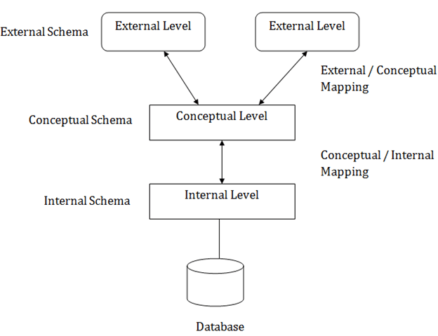
In the above diagram:
- It shows the DBMS architecture.
- Mapping is used to transform the request and response between various database levels of architecture.
- Mapping is not good for small DBMS because it takes more time.
- In External / Conceptual mapping, it is necessary to transform the request from external level to conceptual schema.
- In Conceptual / Internal mapping, DBMS transform the request from the conceptual to internal level.

Objectives of Three schema Architecture
The main objective of three level architecture is to enable multiple users to access the same data with a personalized view while storing the underlying data only once. Thus it separates the user's view from the physical structure of the database. This separation is desirable for the following reasons:
- Different users need different views of the same data.
- The approach in which a particular user needs to see the data may change over time.
- The users of the database should not worry about the physical implementation and internal workings of the database such as data compression and encryption techniques, hashing, optimization of the internal structures etc.
- All users should be able to access the same data according to their requirements.
- DBA should be able to change the conceptual structure of the database without affecting the user's
- Internal structure of the database should be unaffected by changes to physical aspects of the storage.

1. Internal Level
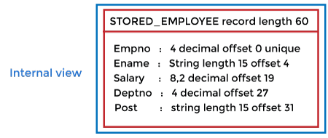
- The internal level has an internal schema which describes the physical storage structure of the database.
- The internal schema is also known as a physical schema.
- It uses the physical data model. It is used to define that how the data will be stored in a block.
- The physical level is used to describe complex low-level data structures in detail.
The internal level is generally is concerned with the following activities:
- Storage space allocations.
For Example: B-Trees, Hashing etc.
- Access paths.
For Example: Specification of primary and secondary keys, indexes, pointers and sequencing.
- Data compression and encryption techniques.
- Optimization of internal structures.
- Representation of stored fields.

2. Conceptual Level
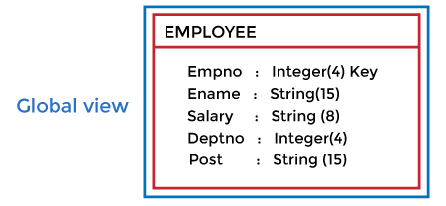
- The conceptual schema describes the design of a database at the conceptual level. Conceptual level is also known as logical level.
- The conceptual schema describes the structure of the whole database.
- The conceptual level describes what data are to be stored in the database and also describes what relationship exists among those data.
- In the conceptual level, internal details such as an implementation of the data structure are hidden.
- Programmers and database administrators work at this level.

3. External Level
- At the external level, a database contains several schemas that sometimes called as subschema. The subschema is used to describe the different view of the database.
- An external schema is also known as view schema.
- Each view schema describes the database part that a particular user group is interested and hides the remaining database from that user group.
- The view schema describes the end user interaction with database systems.

Mapping between Views
The three levels of DBMS architecture don't exist independently of each other. There must be correspondence between the three levels i.e. how they actually correspond with each other. DBMS is responsible for correspondence between the three types of schema. This correspondence is called Mapping.
There are basically two types of mapping in the database architecture:
- Conceptual/ Internal Mapping
- External / Conceptual Mapping
Conceptual/ Internal Mapping
The Conceptual/ Internal Mapping lies between the conceptual level and the internal level. Its role is to define the correspondence between the records and fields of the conceptual level and files and data structures of the internal level.
External/ Conceptual Mapping
The external/Conceptual Mapping lies between the external level and the Conceptual level. Its role is to define the correspondence between a particular external and the conceptual view.

Data Abstraction in DBMS
In this article, we will explore data abstraction in Database Management Systems (DBMS).
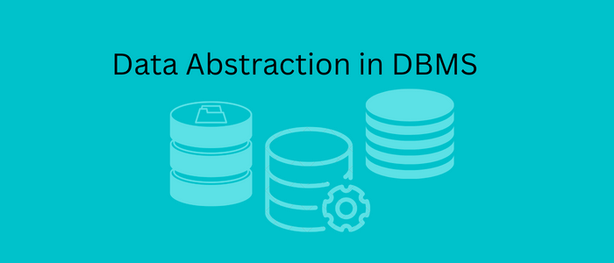
Let us understand the concept of data abstraction.
Data abstraction is the procedure of concealing irrelevant or unwanted data from the end user.
Let us understand this with an example, if you go to a shop to buy a pair of shoes, you ask the shopkeeper to show you the shoes of a certain company, and you also tell the shopkeeper about the size, color, and material you want. Then, you will only see the specified things in the shoes, or will you be asking the shopkeeper questions such as, where are these shoes made? From where does the material come? What is the cost of the material?
Backward Skip 10sPlay VideoForward Skip 10s
The answer to these questions is NO. You will not ask these questions because these questions are of no use. You do not care about these questions. You are only concerned about a few things, such as the company, size, color, material, and how the shoes look. That is why these unimportant details are kept hidden from the end user. This is the process we call data abstraction.

What is Data abstraction in Database Management System?
The database system contains intricate data structures and relations. The developers keep away the complex data from the user and remove the complications so that the user can comfortably access data in the database and can only access the data they want, which is done with the help of data abstraction.
The main purpose of data abstraction is to hide irrelevant data and provide an abstract view of the data. With the help of data abstraction, developers hide irrelevant data from the user and provide them the relevant data. By doing this, users can access the data without any hassle, and the system will also work efficiently.
In DBMS, data abstraction is performed in layers which means there are levels of data abstraction in DBMS that we will further study in this article. Based on these levels, the database management system is designed.

Levels of Data Abstractions in DBMS
In DBMS, there are three levels of data abstraction, which are as follows:
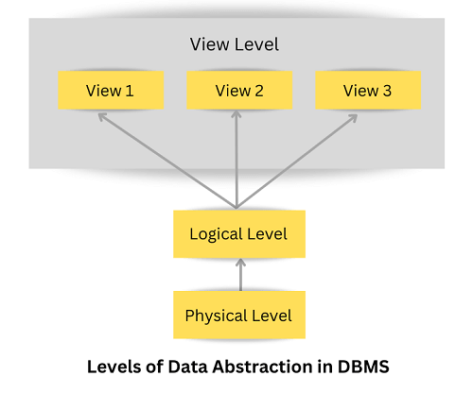

1. Physical or Internal Level:
The physical or internal layer is the lowest level of data abstraction in the database management system. It is the layer that defines how data is actually stored in the database. It defines methods to access the data in the database. It defines complex data structures in detail, so it is very complex to understand, which is why it is kept hidden from the end user.
Data Administrators (DBA) decide how to arrange data and where to store data. The Data Administrator (DBA) is the person whose role is to manage the data in the database at the physical or internal level. There is a data center that securely stores the raw data in detail on hard drives at this level.

2. Logical or Conceptual Level:
The logical or conceptual level is the intermediate or next level of data abstraction. It explains what data is going to be stored in the database and what the relationship is between them.
It describes the structure of the entire data in the form of tables. The logical level or conceptual level is less complex than the physical level. With the help of the logical level, Data Administrators (DBA) abstract data from raw data present at the physical level.

3. View or External Level:
View or External Level is the highest level of data abstraction. There are different views at this level that define the parts of the overall data of the database. This level is for the end-user interaction; at this level, end users can access the data based on their queries.

Advantages of data abstraction in DBMS
- Users can easily access the data based on their queries.
- It provides security to the data stored in the database.
- Database systems work efficiently because of data abstraction.

Conclusion:
- In this article, you have studied data abstraction, which means hiding unwanted details from the end user.
- You have studied the three levels of data abstraction in DBMS: the physical or internal level, the logical or conceptual level, and the visual or external level.
- The physical or internal level describes how data can be stored in the database.
- The logical or conceptual level describes the data being stored in the database.
- The view or external level represents multiple views that users can access based on their questions.

Data Independence
- Data independence can be explained using the three-schema architecture.
- Data independence refers characteristic of being able to modify the schema at one level of the database system without altering the schema at the next higher level.
There are two types of data independence:

1. Logical Data Independence
- Logical data independence refers characteristic of being able to change the conceptual schema without having to change the external schema.
- Logical data independence is used to separate the external level from the conceptual view.
- If we do any changes in the conceptual view of the data, then the user view of the data would not be affected.
- Logical data independence occurs at the user interface level.

2. Physical Data Independence
- Physical data independence can be defined as the capacity to change the internal schema without having to change the conceptual schema.
- If we do any changes in the storage size of the database system server, then the Conceptual structure of the database will not be affected.
- Physical data independence is used to separate conceptual levels from the internal levels.
- Physical data independence occurs at the logical interface level.
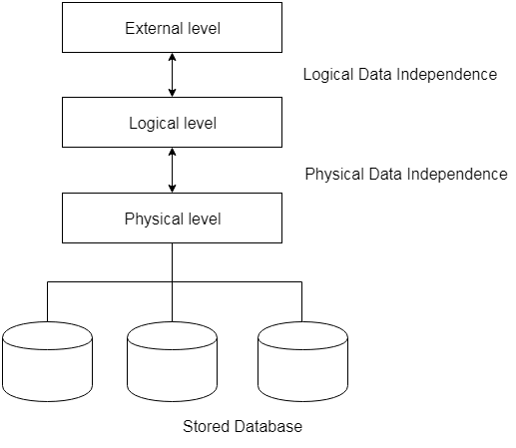
Fig: Data Independence

Structure of DBMS

DBMS
DBMS means Database Management System, which is a tool or software used to create the database or delete or manipulate the database. A software programme created to store, retrieve, query, and manage data is known as a Database Management System (DBMS). Data can be generated, read, updated, and destroyed by authorized entities thanks to user interfaces (UIs).
Because they give programmers, Database Managers, and end users a consolidated view of the data, Database Management Systems are crucial because they relieve applications and end users of the need to comprehend the physical location of the data. Application Programme Interfaces (APIs) manage internet requests and responses for particular sorts of data.
In marketing materials, the phrase "database as a service" (DBaaS) may be used to refer to both relational and non-relational DBMS components that are given via the internet.
Users of DBMSs include application programmers, Database Administrators (DBAs), and end users.
Database Administrators are typically the only people who work directly with a DBMS. Today, end users read and write to databases using front-end interfaces made by programmers, while programmers use cloud APIs to connect with DBMSs.
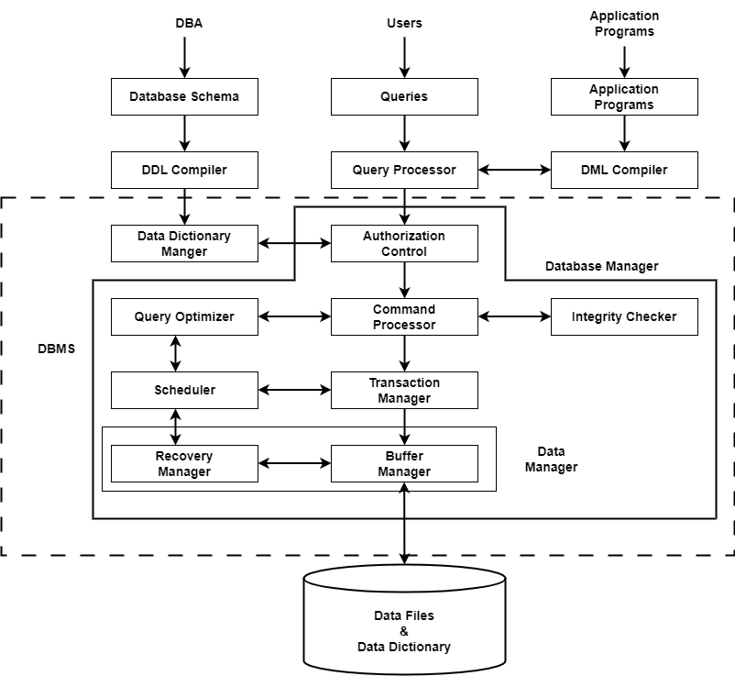
Three Parts that make up the Database System are:
- Query Processor
- Storage Manager
- Disk Storage
The explanations for these are provided below:

1. Query Processor
The query processing is handled by the query processor, as the name implies. It executes the user's query, to put it simply. In this way, the query processor aids the database system in making data access simple and easy. The query processor's primary duty is to successfully execute the query. The Query Processor transforms (or interprets) the user's application program-provided requests into instructions that a computer can understand.

Components of the Query Processor
- DDL Interpreter:
Data Definition Language is what DDL stands for. As implied by the name, the DDL Interpreter interprets DDL statements like those used in schema definitions (such as create, remove, etc.). This interpretation yields a set of tables that include the meta-data (data of data) that is kept in the data dictionary. Metadata may be stored in a data dictionary. In essence, it is a part of the disc storage that will be covered in a later section of this article.
- DML Compiler:
Compiler for DML Data Manipulation Language is what DML stands for. In keeping with its name, the DML Compiler converts DML statements like select, update, and delete into low-level instructions or simply machine-readable object code, to enable execution. The optimization of queries is another function of the DML compiler. Since a single question can typically be translated into a number of evaluation plans. As a result, some optimization is needed to select the evaluation plan with the lowest cost out of all the options. This process, known as query optimization, is exclusively carried out by the DML compiler. Simply put, query optimization determines the most effective technique to carry out a query.
- Embedded DML Pre-compiler:
Before the query evaluation, the embedded DML commands in the application program (such as SELECT, FROM, etc., in SQL) must be pre-compiled into standard procedural calls (program instructions that the host language can understand). Therefore, the DML statements which are embedded in an application program must be converted into routine calls by the Embedded DML Pre-compiler.
- Query Optimizer:
It starts by taking the evaluation plan for the question, runs it, and then returns the result. Simply said, the query evaluation engine evaluates the SQL commands used to access the database's contents before returning the result of the query. In a nutshell, it is in charge of analyzing the queries and running the object code that the DML Compiler produces. Apache Drill, Presto, and other Query Evaluation Engines are a few examples.

2. Storage Manager:
An application called Storage Manager acts as a conduit between the queries made and the data kept in the database. Another name for it is Database Control System. By applying the restrictions and running the DCL instructions, it keeps the database's consistency and integrity. It is in charge of retrieving, storing, updating, and removing data from the database.

Components of Storage Manager
Following are the components of Storage Manager:
- Integrity Manager:
Whenever there is any change in the database, the Integrity manager will manage the integrity constraints.
- Authorization Manager:
Authorization manager verifies the user that he is valid and authenticated for the specific query or request.
- File Manager:
All the files and data structure of the database are managed by this component.
- Transaction Manager:
It is responsible for making the database consistent before and after the transactions. Concurrent processes are generally controlled by this component.
- Buffer Manager:
The transfer of data between primary and main memory and managing the cache memory is done by the buffer manager.

3. Disk Storage
A DBMS can use various kinds of Data Structures as a part of physical system implementation in the form of disk storage.

Components of Disk Storage
Following are the components of Disk Manager:
- Data Dictionary:
It contains the metadata (data of data), which means each object of the database has some information about its structure. So, it creates a repository which contains the details about the structure of the database object.
- Data Files:
This component stores the data in the files.
- Indices:
These indices are used to access and retrieve the data in a very fast and efficient way.

Record-Based Data Model
• Read
• Discuss
• Courses

Data Model is the model that organizes elements of the data and tell how they relate to one-another and with the properties of real-world entities. The basic purpose of the data model is to make sure that the data stored in the data model is understood fully.
Further, it has three types-
1. Physical Data Model,
2. Record-Based Data Model,
3. Object-Oriented Data Model
Physical Data Model is not used much nowadays. In this, we will study about the Record-Based Data Model in detail.
Record-Based Data Model :
When the database is organized in some fixed format of records of several than the model is known as Record-Based Data Model. It has a fixed number of fields or attributes in each record type and each field is usually of a fixed length.
Further, it is classified into three types-
- Hierarchical Data Model :
In hierarchical type, the model data are represented by collection of records. In this, relationships among the data are represented by links. In this model, tree data structure is used.
It was developed in 1960s by IBM, to manage large amount of data for complex manufacturing projects. The basic logic structure of hierarchical data model is upside-down “tree”.
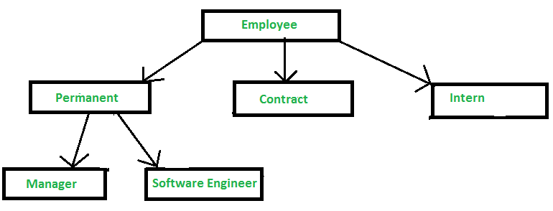
Advantages –
Simplicity, Data Integrity, Data security, Efficiency, Easy availability of expertise.
Disadvantages –
Complexity, Inflexibility, Lack of Data Independence, Lack of querying facility, Data Manipulation Language, Lack Of standards.
- Network Data Model :
In network type, the model data are represented by collection of records. In this, relationships among the data are represented by links. Graph data structures are used in this model. It permits a record to have more than one parent.
For Example- Social Media sites like Facebook, Instagram etc.
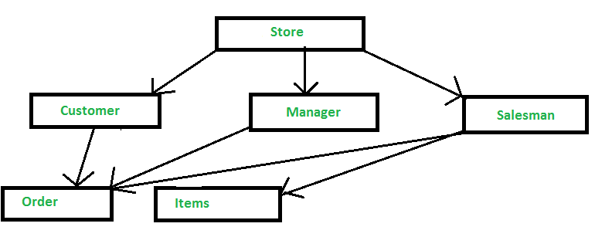
Advantages –
Simplicity, Data Integrity, Data Independence, Database standards.
Disadvantages –
System Complexity, Lack of structural Independence.
- Relational Data Model :
Relational Data Model uses tables to represent the data and the relationship among these data. Each table has multiple columns and each column is identified by a unique name. It is a low-level model.
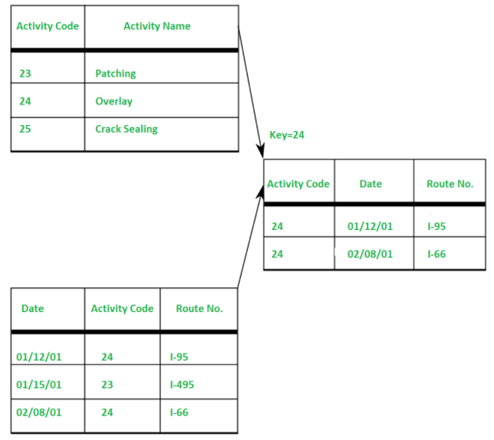
Advantages –
Structural Independence, Simplicity, Ease of designing, Implementation, Ad-Hoc query capability.
Disadvantages –
Hardware Overheads, Ease of design can result in bad design.

ER (Entity Relationship) Diagram in DBMS
- ER model stands for an Entity-Relationship model. It is a high-level data model. This model is used to define the data elements and relationship for a specified system.
- It develops a conceptual design for the database. It also develops a very simple and easy to design view of data.
- In ER modeling, the database structure is portrayed as a diagram called an entity-relationship diagram.
For example, Suppose we design a school database. In this database, the student will be an entity with attributes like address, name, id, age, etc. The address can be another entity with attributes like city, street name, pin code, etc and there will be a relationship between them.
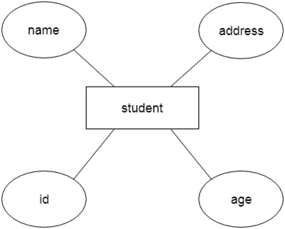

Component of ER Diagram
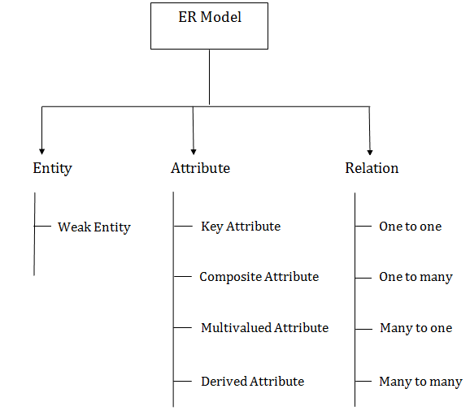

1. Entity:
An entity may be any object, class, person or place. In the ER diagram, an entity can be represented as rectangles.
Consider an organization as an example- manager, product, employee, department etc. can be taken as an entity.
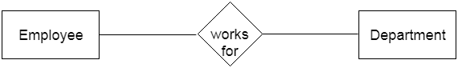
a. Weak Entity
Backward Skip 10sPlay VideoForward Skip 10s
An entity that depends on another entity called a weak entity. The weak entity doesn't contain any key attribute of its own. The weak entity is represented by a double rectangle.
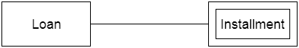

2. Attribute
The attribute is used to describe the property of an entity. Eclipse is used to represent an attribute.
For example, id, age, contact number, name, etc. can be attributes of a student.
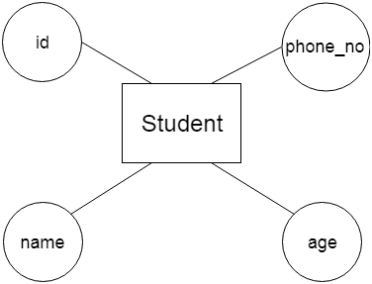

a. Key Attribute
The key attribute is used to represent the main characteristics of an entity. It represents a primary key. The key attribute is represented by an ellipse with the text underlined.
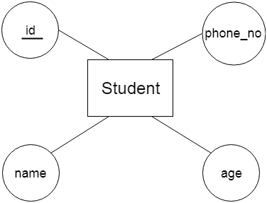
b. Composite Attribute
An attribute that composed of many other attributes is known as a composite attribute. The composite attribute is represented by an ellipse, and those ellipses are connected with an ellipse.
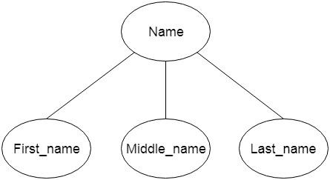
c. Multivalued Attribute
An attribute can have more than one value. These attributes are known as a multivalued attribute. The double oval is used to represent multivalued attribute.
For example, a student can have more than one phone number.
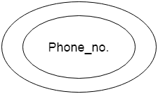
d. Derived Attribute
An attribute that can be derived from other attribute is known as a derived attribute. It can be represented by a dashed ellipse.
For example, A person's age changes over time and can be derived from another attribute like Date of birth.
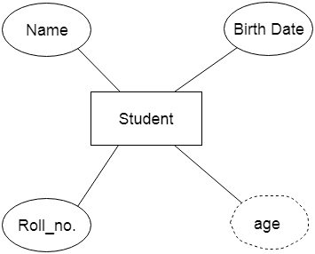

3. Relationship
A relationship is used to describe the relation between entities. Diamond or rhombus is used to represent the relationship.
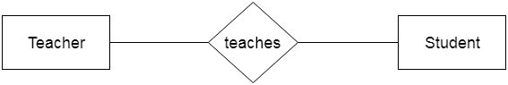
Types of relationship are as follows:
a. One-to-One Relationship
When only one instance of an entity is associated with the relationship, then it is known as one to one relationship.
For example, A female can marry to one male, and a male can marry to one female.
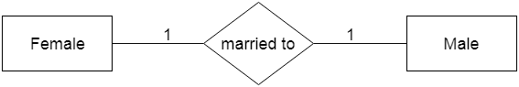
b. One-to-many relationship
When only one instance of the entity on the left, and more than one instance of an entity on the right associates with the relationship then this is known as a one-to-many relationship.
For example, Scientist can invent many inventions, but the invention is done by the only specific scientist.
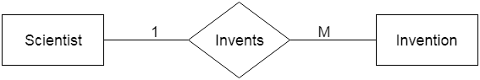
c. Many-to-one relationship
When more than one instance of the entity on the left, and only one instance of an entity on the right associates with the relationship then it is known as a many-to-one relationship.
For example, Student enrolls for only one course, but a course can have many students.
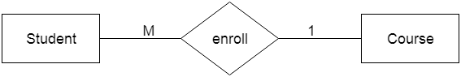
d. Many-to-many relationship
When more than one instance of the entity on the left, and more than one instance of an entity on the right associates with the relationship then it is known as a many-to-many relationship.
For example, Employee can assign by many projects and project can have many employees.
